# Hospital Management System

Nepal Business Collage,

Affiliated to Lincoln University

Final Year Project

By Sujit Kumar Sharma

# Acknowledgment

# Abstract

# Table of Content

Catalog

Hospital Management System 1

Acknowledgment 2

Abstract 3

Table of Content 4

1. Project Overview 5

1.1 Introduction 5

1.2 Objectives: 5

1.3 Features and Functionalists: 5

2. System Architecture Document 7

2.1 Data Flow Diagram 7

2.2 Component Descriptions: 8

3. Requirements Document 11

3.1 Introduction 11

3.2 Resource Requirements: 11

3.3 Functional Requirements Of User: 11

3.4 Assumptions and Dependencies 12

4.Test Case Document 13

4.1. Introduction 13

4.2. Test Case Format 13

4.3. Test Cases 13

4.3.1 User Authentication 13

4.3.2 Admin Dashboard 15

4.3.3 Doctor Dashboard 18

4.3.4 Patient Dashboard 19

5.Design Document 21

5.1. Database Schema 21

5.1.1 User Model (Django's default User model) 21

5.1.2 Doctor Model 21

5.1.3 Patient Model 21

5.1.4 Appointment Model 21

5.1.5 PatientDischargeDetails Model 21

5.2. ER Diagrams 23

6. User Manual 24

6.1 How to Install 24

6.1.1 Clone the Repository 24

6.1.2 Navigate to the Project Directory 24

# Project Overview

### 1.1 Introduction

The Hospital Management System is a web application designed to manage hospital operations efficiently. The system is built using Django for the back-end and HTML, CSS, and JavaScript for the front-end. The application provides distinct functionalists for three types of users: Hospital Admin, Doctor, and Patient.

### ****1.2 Objectives:****

* To provide an intuitive platform for hospital administration, allowing for streamlined processes.
* To create a system where doctors can apply for positions and manage their patient appointments effectively.
* To enable patients to book appointments and manage their hospital interactions seamlessly.
* To automate billing and invoicing for discharged patients.

### ****1.3 Features and Functionalists:****

1. **Admin:**

· **Doctor Management:** Register, view, approve, reject, or delete doctors applying for positions within the hospital.

· **Patient Management:** Admit, view, approve, reject, and discharge patients (discharge patients when treatment is completed).

· **Invoice Management:** Generate and download PDF invoices based on medicine costs, room charges, doctor fees, and additional expenses.

· **Appointment Management:** View, book, and approve patient appointments (approve appointments requested by patients).

1. **Doctor:**

· **Job Application:** Apply for a job within the hospital and log in only after approval from the hospital admin.

· **Patient Management:** View details of patients assigned by the admin, including symptoms, names, and mobile numbers. Access a list of patients who have been discharged (by admin).

· **Appointment Management:** View appointments booked by the admin. Delete appointments after attending to the patient.

1. **Patient:**

· **Account Management:** Create an account to seek admission to the hospital and log in only after approval from the hospital admin.

· **Doctor Information:** View assigned doctor’s details, including specialization, mobile number, and address.

· **Appointment Management:** Check the status of booked appointments (pending/confirmed by admin). Book appointments (approval required from admin).

· **Invoice Management:** View and download PDF invoices only after being discharged by the admin.

# System Architecture Document

### Data Flow Diagram

1. 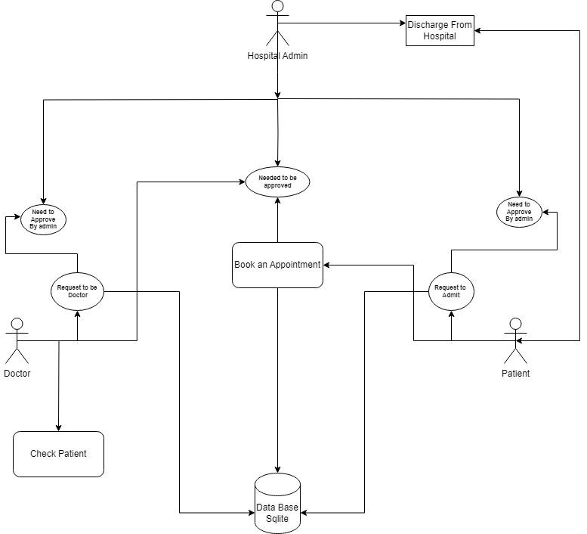
2. Fig: Data Flow diagram of Hospital Management System

### Component Descriptions:

#### 2.2.1 Front-End:

- **Technologies:** HTML, CSS, JavaScript

**- Description:** The Front end is responsible for providing the user interface for all types of users. It includes pages for user authentication, dashboards for admins, doctors, and patients, appointment booking, patient discharge, and invoice viewing/downloading.

**- Key Components:**

* + Login and Registration Forms
  + Admin Dashboard
  + Doctor Dashboard
  + Patient Dashboard
  + Appointment Booking System
  + Invoice Viewing and Downloading
  + Viewing the records
  + Managing the User

#### 2.2.2 Back-End:

* **Technology**: Django (Python)
* **Description:** The Back-end handles the business logic, database interactions, and user management. It processes requests from the Front-end, performs necessary computations, and interacts with the database to store and retrieve data.
* **Key Components:**
  + **User Management:**

1. Admin sign up & Login
2. Doctor sign up & Login
3. Patient sign up & Login
   * **Admin Management:**
     + Admin Dashboard View
     + Doctor Record view (Approve, Update, Delete, reject, add)
     + Patient Record view (Approve, Update, Delete, reject, add) With (discharge, Create Invoice )
     + Approve Appointment
   * **Doctor Management:**
     + Doctor Dashboard View
     + Patient view (view_discharge, delete_appointment, approve_appointment )
     + Search bar
   * **Patient Management:**
     + Patient Dashboard View
     + Book Appointment with choice of (Doctor, Symptoms of Illness, Description )
     + Download Invoice

#### 2.2.2 Database :

* **Technology:** SQLite
* **Description:** The relational database stores all the data related to users (admins, doctors, patients), appointments, invoices, and other related entities.
* **Key Components:**
  + (Admin, Doctor, Patient) Tables are Linked with User Table
  + Appointment Table
  + Patient Discharge Table

#### 2.2.3 External Services:

· **PDF Generation Service:** Used for generating download-able invoices in PDF format. Libraries like Report Lab can be used for this purpose.

· **Security:**

* **Authentication:** Managed using Django's built-in authentication system, which includes user login, registration, and password management.
* **Authorization:** Role-based access control (RBAC) to ensure that only authorized users can access certain functionalists (e.g., only admins can approve doctors and patients).
* **Data Protection:** Implement SSL/TLS for secure data transmission, and follow best practices for data protection and privacy.

# Requirements Document

## 3.1 Introduction

This document outlines the requirements for the Hospital Management System. The system will manage the interactions between hospital admins, doctors, and patients, ensuring efficient administration of hospital activities.

## 3.2 Resource Requirements:

1. **Tools & Technology**:
2. Python
3. Django
4. Pillow, colorama, cryptography, pyparsing, xhtml2pdf, requests, qrcode, django-widget-tweaks
5. js, Css

## 3.3 Functional Requirements Of User:

**A. User Authentication**

* + 1. Admin, doctor, and patient signup.
    2. Login and logout functionalities.
    3. Redirect users to appropriate dashboards after login.

1. **Admin Dashboard**
   * + 1. View counts of doctors, patients, and appointments.
       2. Manage doctor and patient accounts (view, approve, reject, delete).
       3. Add new doctors and patients.
       4. Discharge patients and generate invoices.
       5. Manage appointments (view, approve, reject, add).
2. **Doctor Dashboard:**
   1. View patient details (symptoms, name, mobile).
   2. View discharged patients.
   3. View and manage appointments.
   4. Search for patients by symptoms or name.
3. **Patient Dashboard**
   1. View assigned doctor details (specialization, mobile, address).
   2. Book appointments with doctors.
   3. View appointment status.
   4. View and download invoices.
4. **Appointment Management**
   1. Patients can book appointments with doctors.
   2. Admin can approve or reject appointment requests.
   3. Doctors can view and delete their appointments.
5. **Invoice Generation**
   1. Admin can generate and download PDF invoices for discharged patients.
   2. Invoice includes medicine costs, room charges, doctor fees, and other charges.

## 3.4 Assumptions and Dependencies

1. The system will be developed using Django, HTML, CSS, and JavaScript.
2. The database used will be SQLite.
3. The system will use external services for email notifications and PDF generation.
4. Users will have access to the internet to use the system.
5. The system will be deployed on a web server with SSL/TLS enabled.

# 4.Test Case Document

## 4.1. Introduction

This document outlines the test cases for the Hospital Management System. The purpose of these test cases is to ensure that all functionalities of the system work as expected and meet the specified requirements.

## 4.2. Test Case Format

Each test case is described using the following format:

* **Test Case ID:** Unique identifier for the test case.
* **Test Description:** Brief description of the test case.
* **Preconditions:** Conditions that must be met before the test case is executed.
* **Test Steps:** Step-by-step instructions to execute the test.
* **Expected Result:** The expected outcome of the test case.
* **Actual Result:** The actual outcome after executing the test case.
* **Status:** Pass/Fail based on whether the actual result matches the expected result.

## 4.3. Test Cases

### 4.3.1 User Authentication

#### # TC001

Test Case ID: TC001  
 **Test Description:** Admin Signup  
 **Preconditions:** None  
 **Test Steps:**

1. Navigate to the admin signup page.
2. Fill in the required details (username, password, email, etc.).
3. Submit the signup form.  
   **Expected Result:** Admin account is created, and the user is redirected to the admin login page.

#### # TC002

**Test Case ID:** TC002  
**Test Description:** Admin Login  
**Preconditions:** Admin account exists  
**Test Steps:**

1. Navigate to the admin login page.
2. Enter valid username and password.
3. Submit the login form.  
   **Expected Result:** Admin is logged in and redirected to the admin dashboard.

#### # TC003

**Test Case ID:** TC003  
**Test Description:** Doctor Signup  
**Preconditions:** None  
**Test Steps:**

1. Navigate to the doctor signup page.
2. Fill in the required details.
3. Submit the signup form.  
   **Expected Result:** Doctor account request is created, and the user is redirected to the doctor login page with a pending approval status.

#### # TC004

**Test Case ID:** TC004  
**Test Description:** Doctor Login  
**Preconditions:** Doctor account exists and is approved by admin  
**Test Steps:**

1. Navigate to the doctor login page.
2. Enter valid username and password.
3. Submit the login form.  
   **Expected Result:** Doctor is logged in and redirected to the doctor dashboard.

**Test Case ID:** TC005  
**Test Description:** Patient Signup  
**Preconditions:** None  
**Test Steps:**

1. Navigate to the patient signup page.
2. Fill in the required details.
3. Submit the signup form.  
   **Expected Result:** Patient account request is created, and the user is redirected to the patient login page with a pending approval status.

**Test Case ID:** TC006  
**Test Description:** Patient Login  
**Preconditions:** Patient account exists and is approved by admin  
**Test Steps:**

1. Navigate to the patient login page.
2. Enter valid username and password.
3. Submit the login form.  
   **Expected Result:** Patient is logged in and redirected to the patient dashboard.

### 4.3.2 Admin Dashboard

**Test Case ID:** TC007  
**Test Description:** View Doctor List  
**Preconditions:** Admin is logged in  
**Test Steps:**

1. Navigate to the admin dashboard.
2. Click on the "Manage Doctors" link.  
   **Expected Result:** A list of all doctors (approved and pending) is displayed.

**Test Case ID:** TC008  
**Test Description:** Approve Doctor  
**Preconditions:** Admin is logged in, and there are pending doctor requests  
**Test Steps:**

1. Navigate to the "Approve Doctors" page.
2. Click on the approve button next to a pending doctor.  
   **Expected Result:** The doctor’s status changes to approved.

**Test Case ID:** TC009  
**Test Description:** Reject Doctor  
**Preconditions:** Admin is logged in, and there are pending doctor requests  
**Test Steps:**

1. Navigate to the "Approve Doctors" page.
2. Click on the reject button next to a pending doctor.  
   **Expected Result:** The doctor’s account request is rejected, and the doctor is removed from the list.

**Test Case ID:** TC010  
**Test Description:** Add New Doctor  
**Preconditions:** Admin is logged in  
**Test Steps:**

1. Navigate to the "Add Doctor" page.
2. Fill in the required details.
3. Submit the form.  
   **Expected Result:** A new doctor is added to the hospital, and the doctor’s account is created.

**Test Case ID:** TC011  
**Test Description:** Delete Doctor  
**Preconditions:** Admin is logged in, and there are approved doctors  
**Test Steps:**

1. Navigate to the "Manage Doctors" page.
2. Click on the delete button next to a doctor.  
   **Expected Result:** The doctor is deleted from the hospital, and the doctor’s account is removed.

**Test Case ID:** TC012  
**Test Description:** View Patient List  
**Preconditions:** Admin is logged in  
**Test Steps:**

1. Navigate to the admin dashboard.
2. Click on the "Manage Patients" link.  
   **Expected Result:** A list of all patients (approved and pending) is displayed.

**Test Case ID:** TC013  
**Test Description:** Approve Patient  
**Preconditions:** Admin is logged in, and there are pending patient requests  
**Test Steps:**

1. Navigate to the "Approve Patients" page.
2. Click on the approve button next to a pending patient.  
   **Expected Result:** The patient’s status changes to approved.

**Test Case ID:** TC014  
**Test Description:** Reject Patient  
**Preconditions:** Admin is logged in, and there are pending patient requests  
**Test Steps:**

1. Navigate to the "Approve Patients" page.
2. Click on the reject button next to a pending patient.  
   **Expected Result:** The patient’s account request is rejected, and the patient is removed from the list.

**Test Case ID:** TC015  
**Test Description:** Add New Patient  
**Preconditions:** Admin is logged in  
**Test Steps:**

1. Navigate to the "Add Patient" page.
2. Fill in the required details.
3. Submit the form.  
   **Expected Result:** A new patient is added to the hospital, and the patient’s account is created.

**Test Case ID:** TC016  
**Test Description:** Delete Patient  
**Preconditions:** Admin is logged in, and there are approved patients  
**Test Steps:**

1. Navigate to the "Manage Patients" page.
2. Click on the delete button next to a patient.  
   **Expected Result:** The patient is deleted from the hospital, and the patient’s account is removed.

**Test Case ID:** TC017  
**Test Description:** Discharge Patient  
**Preconditions:** Admin is logged in, and there are patients ready for discharge  
**Test Steps:**

1. Navigate to the "Discharge Patients" page.
2. Click on the discharge button next to a patient.
3. Calculate and confirm the discharge expenses.  
   **Expected Result:** The patient is discharged, and a final bill is generated.

**Test Case ID:** TC018  
**Test Description:** Download Invoice PDF  
**Preconditions:** Admin is logged in, and there are discharged patients with generated invoices  
**Test Steps:**

1. Navigate to the "Discharged Patients" page.
2. Click on the download button next to a patient's invoice.  
   **Expected Result:** The invoice is downloaded as a PDF file.

**Test Case ID:** TC019  
**Test Description:** View Appointment List  
**Preconditions:** Admin is logged in  
**Test Steps:**

1. Navigate to the admin dashboard.
2. Click on the "Manage Appointments" link.  
   **Expected Result:** A list of all appointments (approved and pending) is displayed.

**Test Case ID:** TC020  
**Test Description:** Approve Appointment  
**Preconditions:** Admin is logged in, and there are pending appointment requests  
**Test Steps:**

1. Navigate to the "Approve Appointments" page.
2. Click on the approve button next to a pending appointment.  
   **Expected Result:** The appointment’s status changes to approved.

**Test Case ID:** TC021  
**Test Description:** Reject Appointment  
**Preconditions:** Admin is logged in, and there are pending appointment requests  
**Test Steps:**

1. Navigate to the "Approve Appointments" page.
2. Click on the reject button next to a pending appointment.  
   **Expected Result:** The appointment request is rejected, and the appointment is removed from the list.

**Test Case ID:** TC022  
**Test Description:** Add New Appointment  
**Preconditions:** Admin is logged in  
**Test Steps:**

1. Navigate to the "Add Appointment" page.
2. Fill in the required details.
3. Submit the form.  
   **Expected Result:** A new appointment is added to the hospital's schedule.

**Test Case ID:** TC023  
**Test Description:** Delete Appointment  
**Preconditions:** Admin is logged in, and there are approved appointments  
**Test Steps:**

1. Navigate to the "Manage Appointments" page.
2. Click on the delete button next to an appointment.  
   **Expected Result:** The appointment is deleted from the hospital's schedule.

### 4.3.3 Doctor Dashboard

**Test Case ID:** TC024  
**Test Description:** View Assigned Patients  
**Preconditions:** Doctor is logged in  
**Test Steps:**

1. Navigate to the doctor dashboard.
2. Click on the "Manage Patients" link.  
   **Expected Result:** A list of patients assigned to the doctor is displayed.

**Test Case ID:** TC025  
**Test Description:** Search Patient by Symptoms or Name  
**Preconditions:** Doctor is logged in, and there are patients assigned to the doctor  
**Test Steps:**

1. Navigate to the "Search Patients" page.
2. Enter symptoms or patient's name in the search bar.
3. Submit the search form.  
   **Expected Result:** A list of patients matching the search criteria is displayed.

**Test Case ID:** TC026  
**Test Description:** View Discharged Patients  
**Preconditions:** Doctor is logged in, and there are discharged patients  
**Test Steps:**

1. Navigate to the "View Discharged Patients" page.  
   **Expected Result:** A list of patients discharged by the doctor is displayed.

**Test Case ID:** TC027  
**Test Description:** View Appointments  
**Preconditions:** Doctor is logged in  
**Test Steps:**

1. Navigate to the doctor dashboard.
2. Click on the "Manage Appointments" link.  
   **Expected Result:** A list of appointments assigned to the doctor is displayed.

**Test Case ID:** TC028  
**Test Description:** Delete Appointment  
**Preconditions:** Doctor is logged in, and there are appointments assigned to the doctor  
**Test Steps:**

1. Navigate to the "Manage Appointments" page.
2. Click on the delete button next to an appointment.  
   **Expected Result:** The appointment is deleted from the doctor's schedule.

### 4.3.4 Patient Dashboard

**Test Case ID:** TC029  
**Test Description:** View Assigned Doctor Details  
**Preconditions:** Patient is logged in  
**Test Steps:**

1. Navigate to the patient dashboard.
2. Click on the "View Doctor" link.  
   **Expected Result:** Details of the assigned doctor (specialization, mobile, address) are displayed.

**Test Case ID:** TC030  
**Test Description:** Book Appointment  
**Preconditions:** Patient is logged in  
**Test Steps:**

1. Navigate to the "Book Appointment" page.
2. Fill in the required details (date, time, doctor, symptoms).
3. Submit the form.  
   **Expected Result:** The appointment request is created and awaits admin approval.

**Test Case ID:** TC031  
**Test Description:** View Appointment Status  
**Preconditions:** Patient is logged in, and there are booked appointments  
**Test Steps:**

1. Navigate to the "View Appointments" page.  
   **Expected Result:** A list of booked appointments with their status (pending/confirmed) is displayed.

**Test Case ID:** TC032  
**Test Description:** Download Invoice PDF  
**Preconditions:** Patient is logged in, and the patient has been discharged with a generated invoice  
**Test Steps:**

1. Navigate to the "View Invoice" page.
2. Click on the download button next to the invoice.  
   **Expected Result:** The invoice is downloaded as a PDF file.

# 5.Design Document

## 5.1. Database Schema

### 5.1.1 User Model (Django's default User model)

* username
* password
* first_name
* last_name
* email

### 5.1.2 Doctor Model

* User_id: OneToOneField(User)
* profile_pic: ImageField
* address: CharField
* mobile: CharField
* department: CharField (choices: Cardiologist, Neurologist, Orthopedic, etc.)
* status: BooleanField

### 5.1.3 Patient Model

* user: OneToOneField(User)
* profile_pic: ImageField
* address: CharField
* mobile: CharField
* symptoms: CharField
* assignedDoctorId: PositiveIntegerField
* admitDate: DateField
* status: BooleanField

### 5.1.4 Appointment Model

* patientId: PositiveIntegerField
* doctorId: PositiveIntegerField
* patientName: CharField
* doctorName: CharField
* appointmentDate: DateField
* description: TextField
* status: BooleanField

### 5.1.5 PatientDischargeDetails Model

* patientId: PositiveIntegerField
* patientName: CharField
* assignedDoctorName: CharField
* address: CharField
* mobile: CharField
* symptoms: CharField
* admitDate: DateField
* releaseDate: DateField
* daySpent: PositiveIntegerField
* roomCharge: PositiveIntegerField
* medicineCost: PositiveIntegerField
* doctorFee: PositiveIntegerField
* otherCharge: PositiveIntegerField
* total: PositiveIntegerField

## 5.2. ER Diagrams

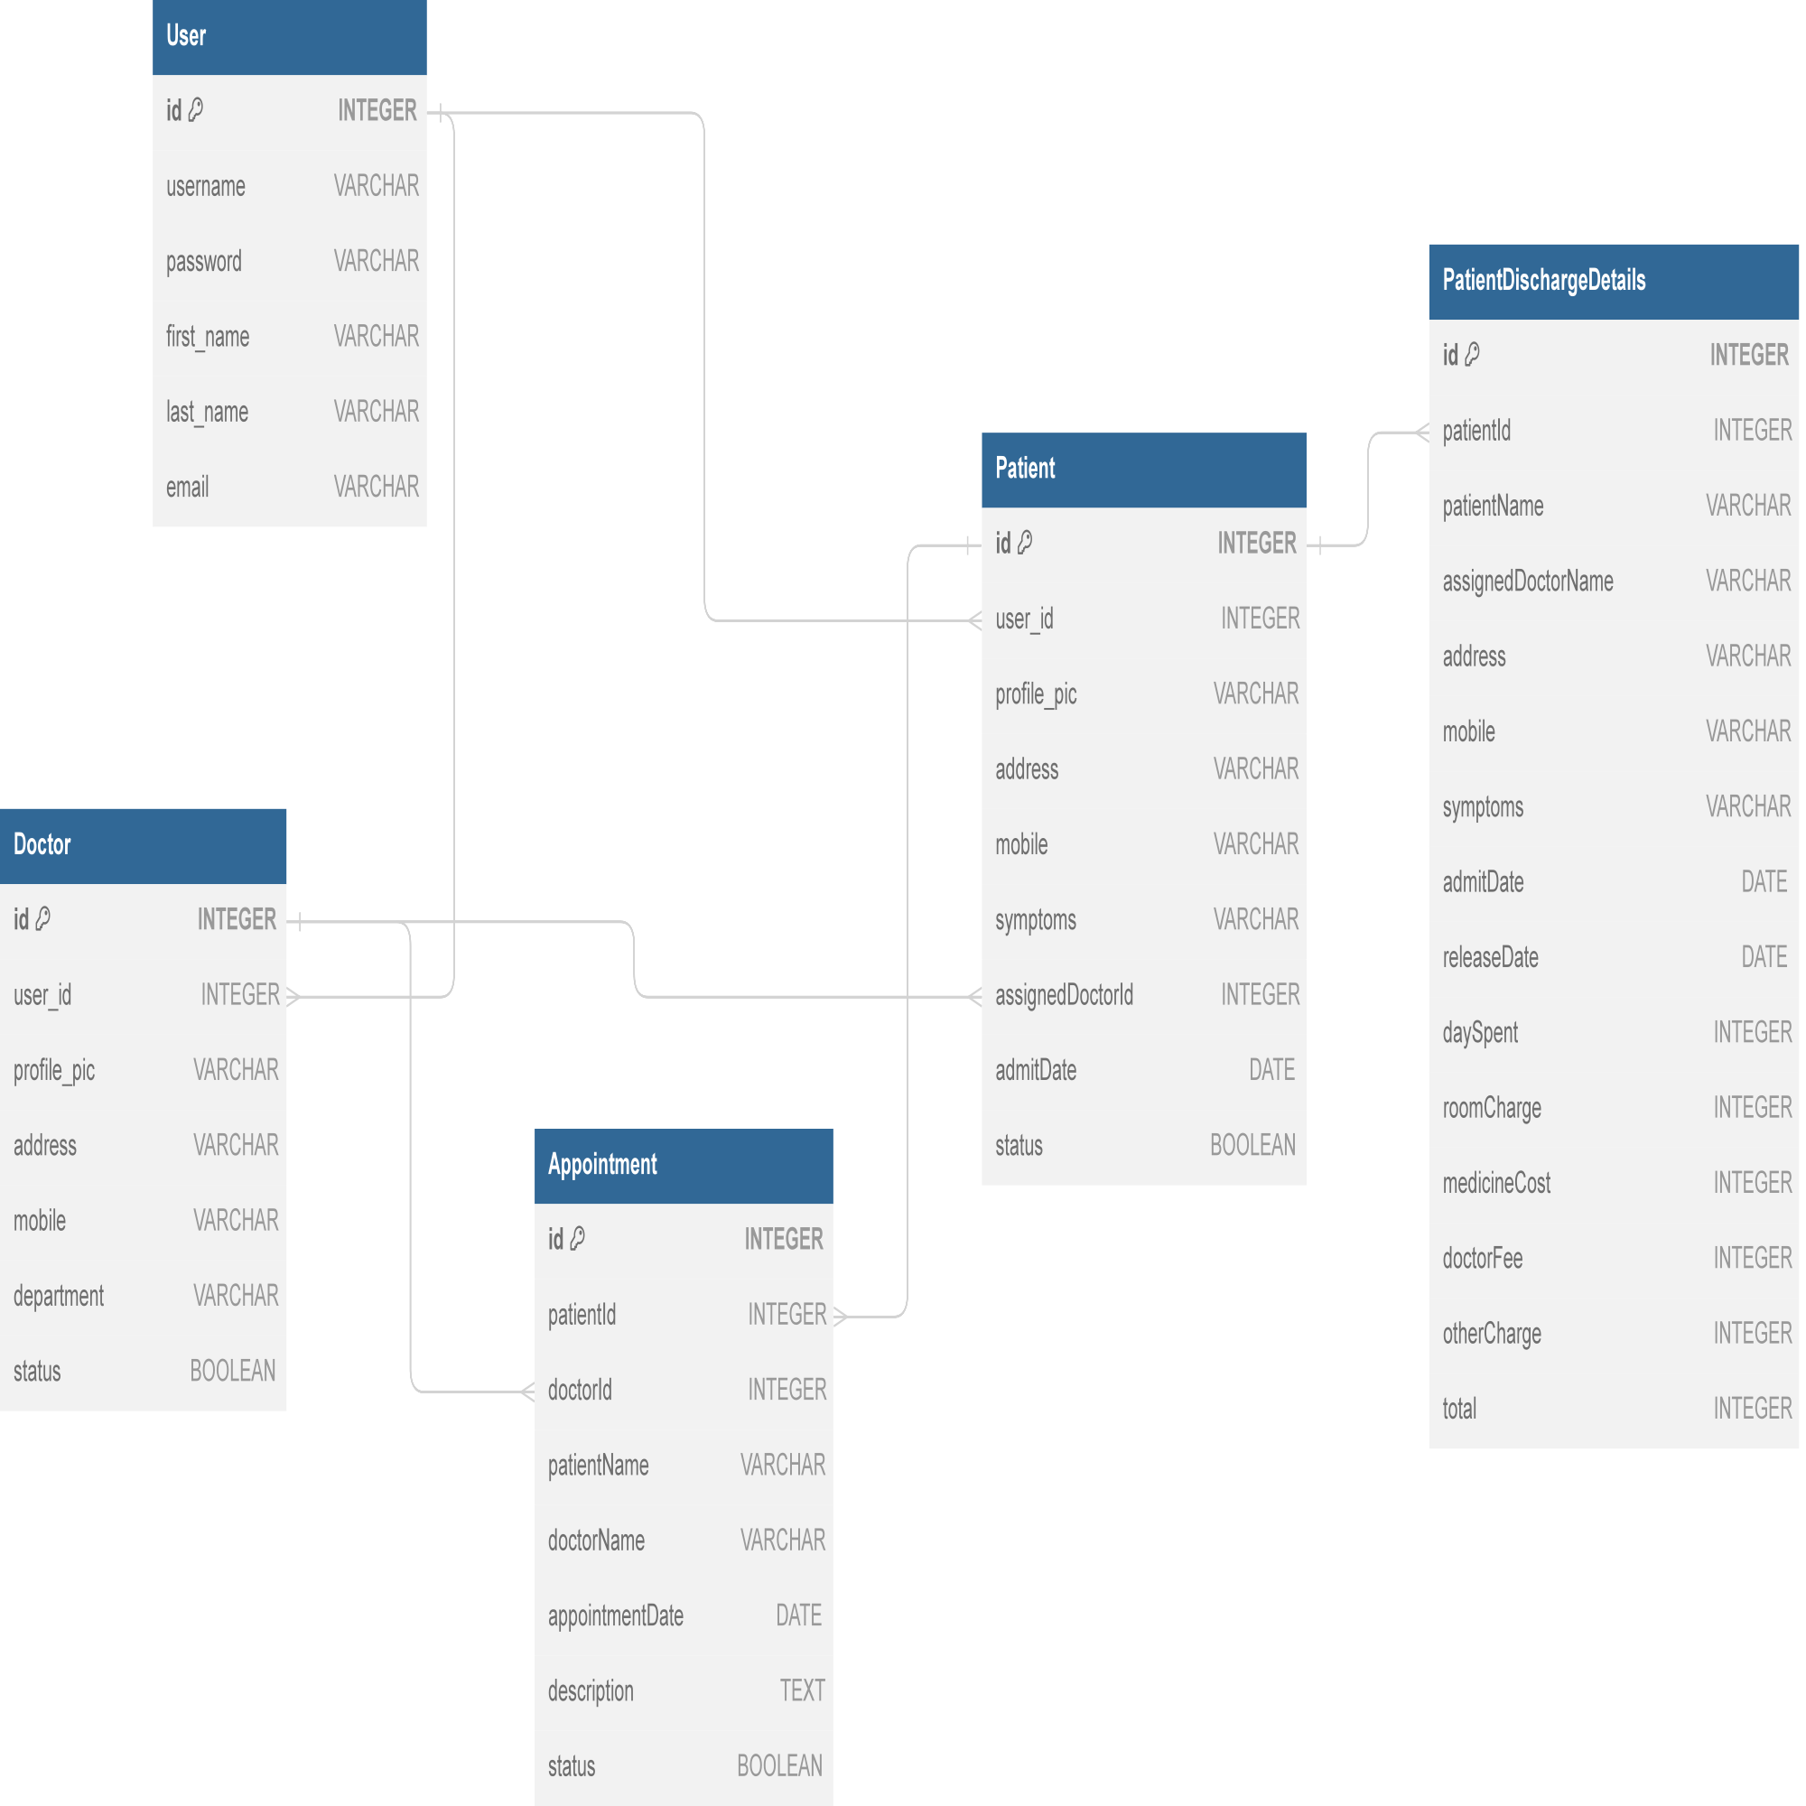

Fig: ER diagram of Hospital Management System

# User Manual

## 6.1 How to Install

### 6.1.1 Clone the Repository

* Open your terminal or command prompt.
* Navigate to the directory where you want to clone the repository.
* Run the following command:

git clone https://github.com/0luv69/Hospital-Mangement-System.git

### 6.1.2 Navigate to the Project Directory

* Change your directory to the newly cloned project: